Interpreting Inner Core Attenuation Scattering through Ultrasonic Experiments

**Ming Gong and Michael I. Bergman, Simon’s Rock College**

# Abstract

We studied experimentally scattering of ultrasonic compressional waves in a hexagonal close-packed Zn-rich Sn alloy, as an analog to the Fe alloy in Earth’s inner core. The goal is to better understand the origin of inner core seismic attenuation, which can be intrinsic or due to scattering. Using the pulse-echo technique, we defined a scattering quality factor *QZ = (R + T)/R*, where *R* and *T* are the average reflected and transmitted energy per cycle. We examined *QZ* for two microstructures that are likely relevant to the inner core: textured, columnar dendritic crystals typical of directional solidification and untextured, equiaxed, ‘fine-grained’ crystals typical of deformation (which can also lead to a texture, leading to an anisotropic *QZ*). We also studied the wavelength dependence of scattering for these two microstructures.

Scaling *QZ* from the laboratory experiments to the inner core depends on the single crystal wave speed anisotropy, *Vc - Va*, which is known for Zn, but uncertain for Fe under inner core conditions. Using *(VcIC - VaIC)/VICaverage* = 10%, we find that for a directionally solidified inner core, *QZIC* is highly anisotropic, with *QZIC* > 20,000 in the growth direction, and 80 < *QZIC* < 1400 in the transverse directions, with the actual value likely closer to the lower end. Based on seismic values of *QP* (which measure the combined effects of anelasticity and scattering), scattering attenuation is likely small compared with intrinsic attenuation in the growth direction but comparable to or even greater than in the transverse directions. For fine-grained crystals, *QZ* is strongly dependent on the grain size. We predict maximum scattering occurs for inner core grain sizes between roughly .5 km and a few kilometers, with a value of *QZIC* = 80, which is lower than is observed, so might not be tenable. For grain sizes much less than .5 km, or larger than a few kilometers, *QZIC* rises to as large as 4800. Because anelasticity seems less likely than microstructure to vary laterally, we suggest lateral variations in *QP* are primarily driven by lateral variations in microstructure, reflecting inner and outer core dynamics.

# Introduction

Earth’s inner core seismic attenuation is a complicated and often perplexing subject. There are questions about its depth dependence, hemispherical and smaller-scale lateral variations, anisotropy, the possible discrepancy between attenuation of low frequency (.0001 - .01 Hz) normal modes and high frequency (.1 – 10 Hz) body waves, and whether the attenuation is intrinsic (anelastic) or due to scattering. The uncertainty about inner core seismic attenuation may also be related to questions about its shear wave (and hence shear modulus) and viscosity.

Intrinsic attenuation is typically quantified by a quality factor *Q = U/ΔU*, the average energy per cycle divided by the energy loss per cycle. The higher the *Q*, the less the anelastic attenuation. For compressional (P) waves, intrinsic attenuation *QP-1* can be in shear *Qμ-1* or in bulk *Qκ-1*, which add in parallel as

*QP-1 = LQμ-1 + (1 – L)Qκ-1*, (1)

where *L = 4VS2/3VP2*, *VS = (μ/ρ)1/2*, *VP = ((κ + 4μ/3)/ρ)1/2*, *VS* and *VP* are the shear and compressional wave velocities, *μ* and *κ* are the shear and bulk moduli, and ρ is the density (*Anderson, 1989*). For shear (S) waves, the intrinsic attenuation *QS-1* is simply

*QS-1 = Qμ-1*. (2)

Shear attenuation is generally due to the lateral motion of lattice defects, grain boundaries, and fluids, while bulk attenuation is largest in regions with phase transitions. Although Morozov (*2015*) has pointed out that the dissipation (inelastic) parameters *Qμ-1* and *Qκ-1* are not true constitutive material properties but rather are based on analogies with elastic parameters, they are useful as a measure of attenuation.

Although some early normal mode studies found a *Qμ* > 1000, whereas body wave studies found a much more attenuating inner core, *Qμ* ~ 40, the former was sensitive to the whole inner core and the latter to the upper few hundred kilometers (*Romanowicz & Mitchell, 2007*). Widmer *et al.* (*1991*) and Talavera*-*Soza (*2020*) reduced the discrepancy by carefully selecting core modes and allowing mode cross-coupling, finding *Qμ* = 84 - 110, though a few body wave studies (*Wookey & Helffrich, 2008; Cao & Romanowicz, 2009*) actually found a much higher *Qμ*, 200 – 315, using the small amplitude PKJKP phase, which gives a direct measure of *Qμ*. The discrepancy between body waves and normal modes highlights the depth dependence of *QP*, which generally increases with depth.

Using both body waves and normal modes, the PREM model (*Dziewonski & Anderson, 1981*) estimated an overall inner core *Qκ* = 1327 and *Qμ* = 85. Equation (1) then yields *QP* = 448 for *VP* = 11.10 km/s and *VS* = 3.55 km/s. For compressional waves, the contribution of attenuation in shear is thus about 2.5 times of that in bulk. Model AK135 (*Kennett et al., 1995*) estimated *Qκ* = 626 and *Qμ* = 85, and hence *QP* = 338. Pejic *et al.* (*2017*) summarized *QP* for the upper inner core from eleven body wave studies. Those that average the entire upper inner core give *QP* = 150 - 1000, though generally in the 200 - 400 range. Some studies also examined hemispherical differences in the upper inner core, finding *QP* generally ranging from 300 - 600 in the western hemisphere, and 160 - 300 in the eastern, though with one study going as high as *QP* = 1000 (*Tanaka, 2012*). Pejic *et al.* (*2017*) emphasize, however, that attenuation in the upper inner core is likely more complex than simply hemispherical.

The contribution of scattering attenuation to *QP*, not included in Equation (1), is uncertain. Pulse broadening and frequency-dependent PKIKP amplitudes are indicative of scattering (*Cormier et al., 1998; Cormier & Li, 2002; Iritani et al., 2014*). By stacking codas following PKiKP pre-critical reflections, Vidale & Earle (*2000*) found evidence for inner core scattering, and suggested that the scattering is volumetric rather than caused by inner core boundary topography, as argued by Poupinet & Kennett (*2004*). Subsequent studies (*Leyton & Koper, 2007; Wu & Irving, 2017; Wu et al. 2022; Wang & Vidale, 2022*) have supported volumetric inner core scattering, including hemispherical and regional variations.

Geodynamical interest in the inner core took off after the inference of inner core elastic anisotropy. Cylindrical anisotropy, whereby compressional waves travel faster in the polar direction than nearly parallel to the equatorial plane, is seen in both body waves (*Poupinet et al., 1983; Morelli et al., 1986*) and normal modes (*Woodhouse et al., 1986*). Amazingly, considering its small amplitude, the PKJKP phase has also been found to exhibit inner core elastic anisotropy (*Wookey & Helffrich, 2008; Wang & Tkalcic, 2021*).

Using compressional body wave amplitude ratios, Souriau & Romanowicz(*1996;1997*) also found an attenuation anisotropy that is anti-correlated with the elastic anisotropy, *i.e.*, waves in the fast polar direction are more attenuating (higher *QP-1*) than those in an equatorial direction. This is perhaps somewhat unexpected if the attenuation is primarily intrinsic, as one might expect the elastically slow direction in an anisotropic crystal to be more attenuating (for instance, regions of the upper mantle that are warmer and hence seismically slower are more attenuating (*Roth et al., 2000*), though temperature is not the obvious cause within a single anisotropic crystal). In an attempt to explain the cylindrical elastic anisotropy, Bergman (*1997*) suggested solidification texturing resulting from dendritic columnar crystals with a tendency to grow elongated perpendicular to the spin axis, due to outer core rotating convection. Bergman(*1998*) found a consequence of such growth might also be an attenuation anisotropy due to an anisotropy of scattering, an idea further pursued by Cormier & Li(*2002*).

Using anelastic splitting functions, Makinen & Deuss (*2013*) also found evidence in normal modes for inner core attenuation anisotropy, with the fast polar direction more attenuating. Because these modes are not sensitive to the plausible length scale of scattering grains, which ranges from tens of meters to tens of kilometers (*Bergman, 1998; Calvet & Margerin, 2008*), the attenuation anisotropy observed in normal modes would seem to be intrinsic, though possible causes such as anisotropic anelasticity associated with the motion of substitutional light element solute atoms in Fe-rich crystals remain speculative (*Makinen et al., 2014*).

As with isotropic attenuation, the simple seismic picture of cylindrical elastic anisotropy has grown more complicated, with depth, hemispherical, and smaller-scale lateral variations (for reviews, see *Deuss, 2014; Tkalcic, 2015*). Seismologists have also now found lateral variations of isotropic velocity and attenuation anisotropy, with faster velocities generally correlated with more attenuation both in position and direction (*Tanaka & Hamaguchi, 1997; Wen & Niu, 2002; Cormier, 2007; Yee et al., 2014*).

This study investigates experimentally ultrasonic compressional wave scattering in hexagonal close-packed (hcp) Zn-rich Sn alloys at room temperature and atmospheric pressure. We used an hcp Zn-rich Sn alloy at room temperature and atmospheric pressure as hcp is the most likely phase of Fe under inner core conditions (*Tateno, et al., 2010*), though others (*Vocadlo et al., 2003; Belonoshko, et al., 2017*) have suggested the body-centered cubic phase could be stable, especially with the presence of light elements. The structure of directionally solidified hcp alloys is one of columnar crystals (*i.e.*, they have a pronounced shape-preferred anisotropy), with each elongated crystal composed of dendrites (platelets) parallel to the basal plane and to the growth direction (*i.e.*, they also have a lattice-preferred orientation). The c-axes are thus transverse to the growth direction, randomly oriented between different crystals, in the absence of fluid flow (*Bergman et al., 2003*). On the other hand, deformation, dynamic recrystallization, and annealing are more likely to produce fine-grained, equiaxed crystals (*Cormier et al., 2022*). The ‘fine-grained’ crystals in the inner core could still be quite large, but small compared to columnar crystals. Depending on the deformation mechanism, they may or may not have a lattice-preferred orientation.

We use the pulse-echo technique to quantify the energy in reflected and transmitted waves for these two different microstructures that could plausibly be present in Earth’s inner core: dendritic, textured, columnar crystals, and untextured, fine-grained, equiaxed crystals. This enables us to calculate a quality factor for scattering, *QZ* (or *QZ-1* for scattering attenuation), for the two microstructures in our experiments, and, based on the expected impedance contrasts in our experiments and in the inner core, predict *QZ* for different microstructures in the inner core. The goal is to experimentally understand the role of scattering for inner core attenuation and to seismologically help discern the grain morphology in the inner core.

# Procedures

We first produced 1500 g Zn-3-wt-pct-Sn ingots, each with a diameter of 4.4 cm, by melting 99.9% Zn and 99.99% Sn together in a graphite crucible within a resistance furnace. To achieve a dendritic, textured, columnar microstructure, we then remelted an ingot and directionally solidified it at a cooling rate of 1.0 K/min. The initial temperature gradient was 6.8 K/cm, but it decreased as the overall temperature cooled because the furnace was fixed rather than being of a Bridgman type. To achieve an untextured, fine-grained, equiaxed microstructure, we stirred the melt as it solidified, much as one makes ice cream. Although there remains a nominal temperature gradient in the furnace, it became functionally insignificant in the melt due to constant stirring and rapid cooling, which we confirmed with microscopy. We produced two ingots for each of the two microstructures.

From each ingot, we then machined a cube with an edge length of 3.5 cm, parallel to within .0127 mm. Using standard metallographic techniques, we polished each cube face flat to 5 μm for ultrasonics testing. We further polished some faces to 0.3 μm, at which the grain structure becomes visible, with the Zn-rich phase appearing dark, and the eutectic along grain and dendrite boundaries appearing light (Figures 1 and 2). We then divided each face of a cube into nine images arranged in a 3-by-3 grid using a reflection microscope.

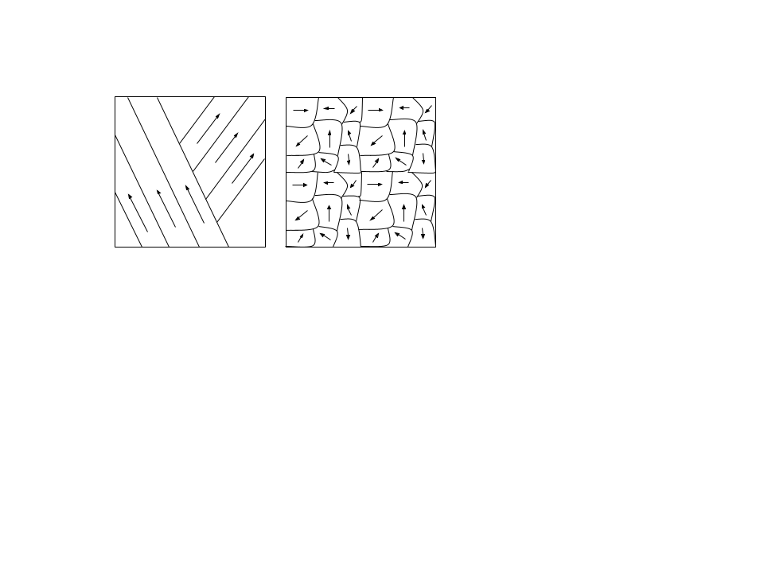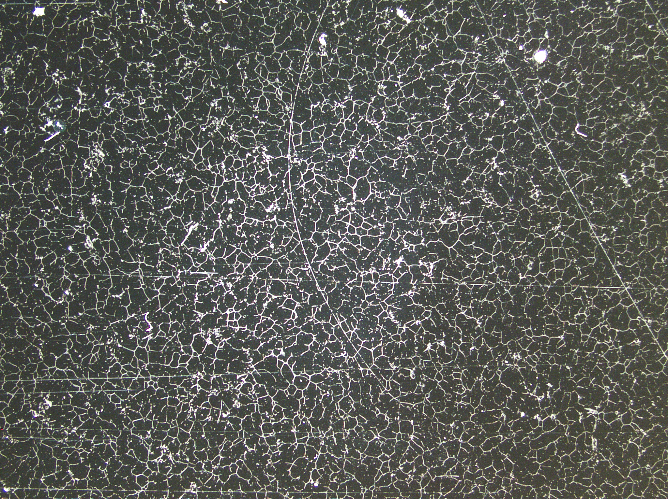

Figure 1. a) Diagram and b) micrograph of untextured, fine-grained, equiaxed crystals. The Zn-rich phase is dark, the eutectic light. In Figures 1a and 2a the arrows show the a-axis direction of an hcp Zn crystal.

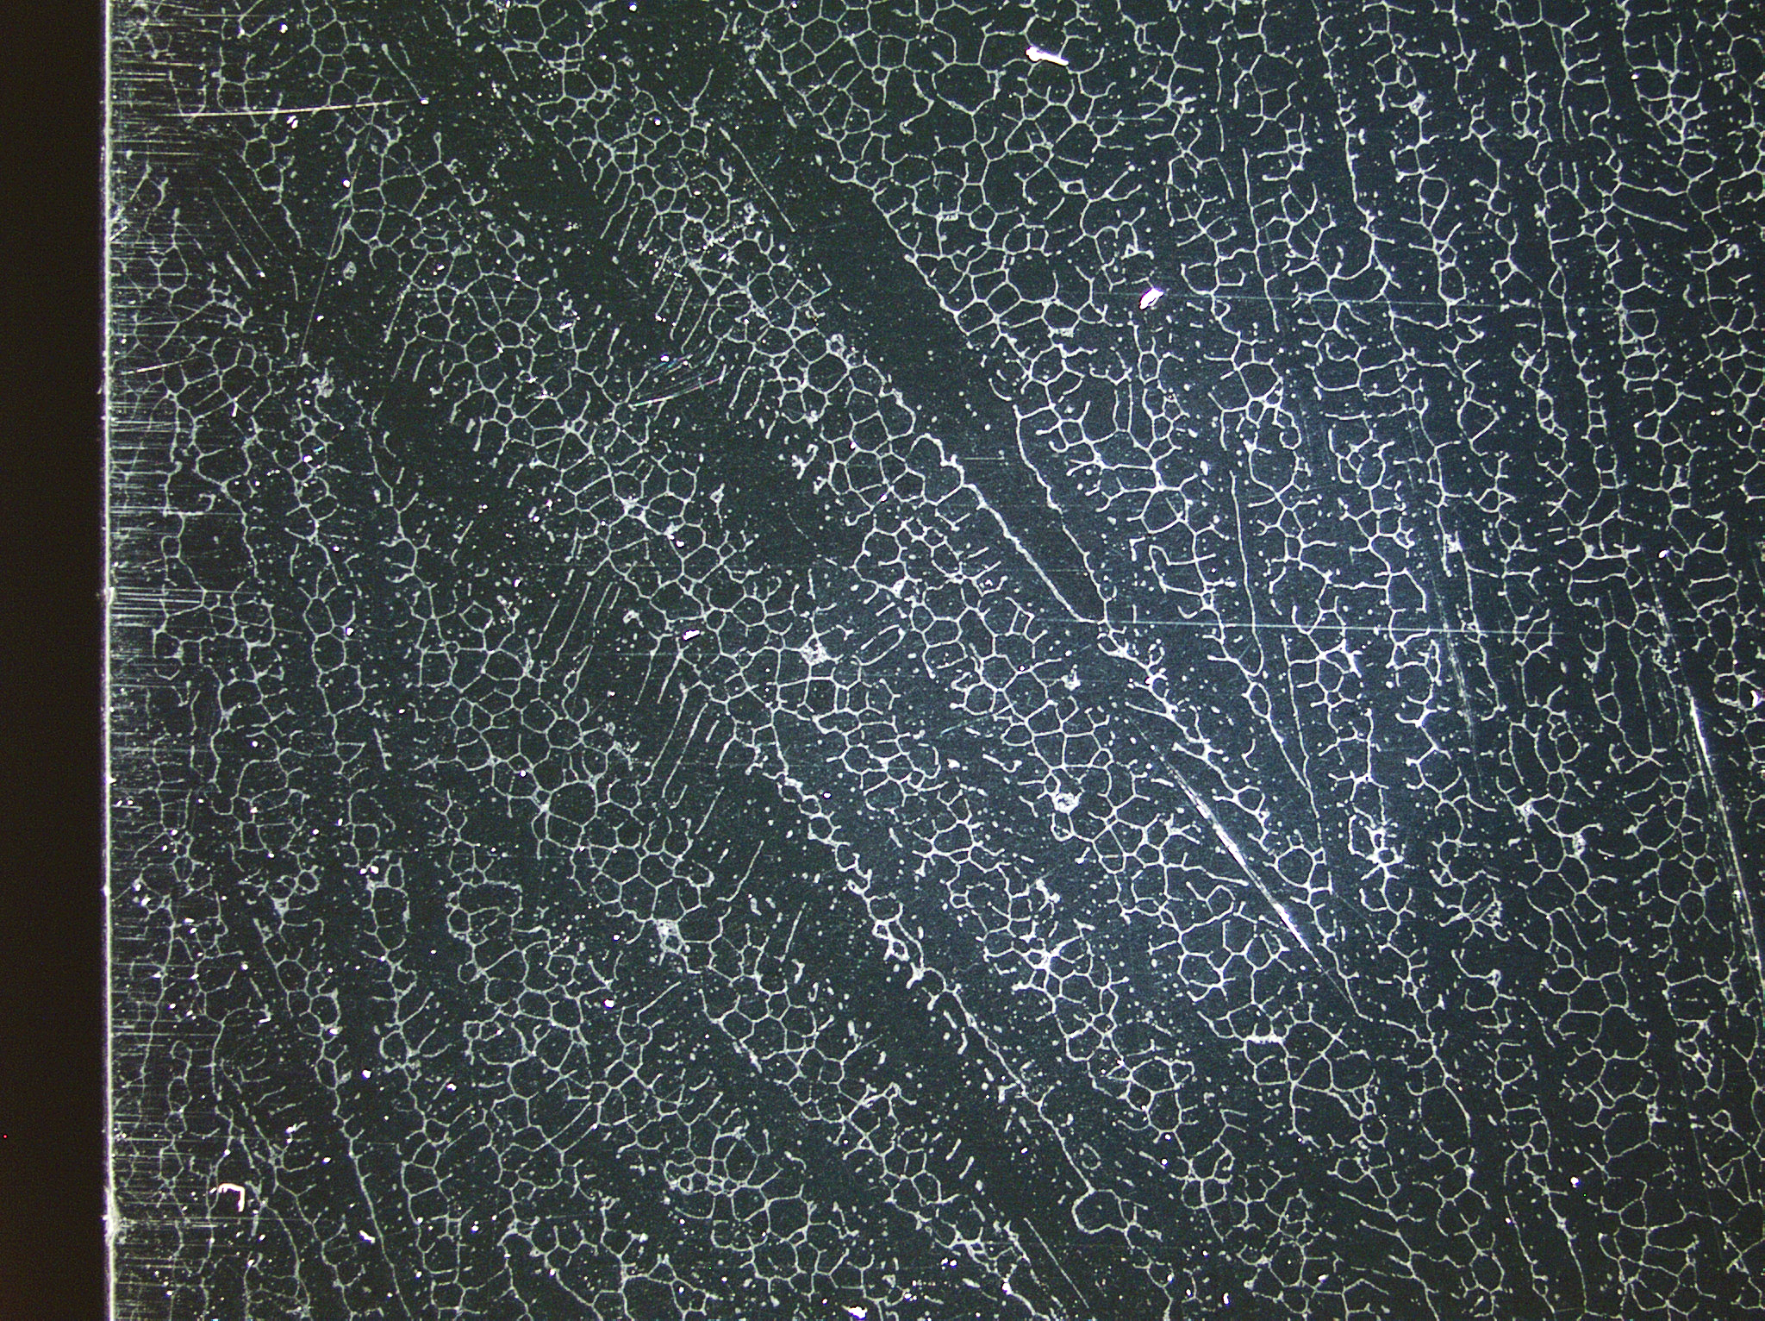

Figure 2. a) Diagram and b) micrograph of dendritic, textured, columnar crystals. The growth direction is vertical, but the columnar crystals are not perfectly aligned.

We used ImageJ for image analysis to estimate the average grain size. For each image, we overlaid two horizontal and two vertical lines and counted the number of grain boundary intersections with each line. The average grain width for a given line is calculated by dividing the line’s length by the total number of intersections. Finally, we calculated the mean and standard deviation for the grain width in each direction in each cube face, enabling us to determine the grain size and observe the grain shape anisotropy.

To study the scattering of ultrasonic compressional waves in the cubes, we used Matec Instruments RHP-8000 high-power toneburst pulser/receiver to perform the pulse-echo technique (*McSkimin, 1950*), where reflections of a gated toneburst off the back side of a cube are received by the output transducer on the front side (Figure 3). We used general-purpose PZT (lead zirconate titanate) P-wave transducers with backing for damping, with four fundamental frequencies: 1.0 MHz (piezo crystal diameter 1.27 cm), 2.25 MHz (.95 cm), 5.0 MHz (.95 cm), and 10.0 MHz (.64 cm). For each measurement, the transducer was directly coupled to the cube without a buffer, using an industrial ultrasonic couplant (Sonotech). In this study, we observed scattering at room temperature, but in the future, we will look at scattering at elevated temperatures where there is interdendritic and intergranular melt, using a dry foil coupling technique that we have been developing that is suitable for elevated temperatures (*Bhadwal et al., 2019*).

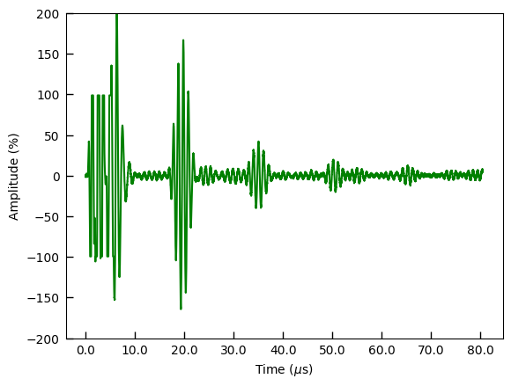

Figure 3. Multiple 1.0 MHz compressional wave gated pulse-echoes off the back side of a directionally solidified Zn-3 wt-pct Sn cube in the growth direction. The amplitude scale is arbitrary, as it is a function of the actual input power and the amplifier gain.

We found that setting the number of cycles in a pulse to three produced the cleanest results. It is important to emphasize that whereas a gated toneburst would ideally have the desired number of cycles with no noise, in practice, even with damping, the electrical signal inevitably causes acoustic crystal ringing that can obfuscate the scattering of the acoustic wave of interest. Setting too many cycles can overwhelm the scattering one is trying to observe, while too few can make the reflected pulse difficult to identify above the noise and scattering. We set the repetition rate, which is not a crucial parameter, to 50.0 ms, long enough to not interfere with multiple pulse reflection transits. We set the input power to approximately 80% of the threshold that transducers might begin to overheat.

We made measurements at each of the four frequencies on four cubes: two directionally solidified (d.s) and two fine-grained (f.g.). On each d.s. cube, we measured the ultrasonic waves traveling parallel to the growth direction and on waves in two perpendicular transverse directions. On each f.g. cube, we measured in the vertical (*i.e.*, in the direction of nominal solidification) and in one side (transverse) direction, with the expectation that all three directions should yield similar results since the fine-grained alloy should, in theory, be isotropic.

Although quality factors are just parameterizations, they are a useful measure of attenuation. For our experiments, we define *QZ = (R + T)/R*, where *R* and *T* are the average reflected and transmitted energy per cycle. The reflected energy results from impedance contrasts (acoustic impedance *Z = ρV*, where *ρ* is the density and *V* is the seismic velocity), such as might arise at grain boundaries of imperfectly textured anisotropic crystals. Unlike intrinsic attenuation, mechanical energy is conserved. Therefore, our definition of *QZ* follows from the premise that *R* *+ T* represents the total mechanical energy, with *R* being the portion of the mechanical energy not transmitted forward as a signal. Note, however, that multiple scatterers can result in forward scattering and, hence, a transmitted coda (which, unlike in seismology, we are not looking at). Since intrinsic and scattering attenuation are essentially independent, one would expect overall attenuation to add in inverse, *i.e.*,

*QP-1 = LQμ-1 + (1 – L)Qκ-1 + QZ-1*. (3)

This poses a challenge for seismologists to unravel the relative contributions of intrinsic and scattering attenuation (*Wu et al., 2022*).

We divided each face used for measurement into a 3-by-3 grid. For each spot in the grid, we recorded the wavetrain digitally, sampling the amplitude at 10 ns intervals. We designed an algorithm to systematically identify pulse reflections. To identify the start of a pulse-echo, we required a region of consecutive points to have amplitudes (relative to the rest of the wave train) larger than a preset value. In case the echo was unclear, as was sometimes the case when there was a lot of scattering, we manually identified the pulse reflection that occurred closest to the calculated travel time.

The time interval between the end of the incident pulse and the start of the first echo is identified as the “reflected scattering interval,” and the interval between the start and end of the first echo is identified as the “transmitted pulse interval.” As discussed, due to ringing, the incident acoustic pulse typically has more than the set number of three cycles, as does then the transmitted pulse (for instance, at 1.0 MHz, the incident and transmitted pulse intervals are typically about 6 μs in duration rather than 3 μs, Figure 4). To be consistent, for a given frequency, we kept the same duration for the transmitted pulse interval, even if the signal and ringing might vary slightly. Although we often saw multiple echoes (Figure 3), especially when there was less scattering, we used the first echo for calculating *QZ* since it is, of course, the largest.

We squared the amplitude values and integrated them using the trapezoidal method to calculate the energy in each interval. To account for some smaller additional ringing after the incident pulse (for instance, persisting until approximately 9 μs at 1.0 MHz, Figure 4), we excluded this region from the scattering integration. We then computed the average energy per cycle in each interval by dividing the interval’s integrated energy by its time duration, which we denote *R* for average reflected (scattered) energy per cycle and *T* for average transmitted energy per cycle. Finally, we calculated *QZ = (R + T)/R* for each waveform.

# Results

## 3.1. Grain Size

Table 1 shows the results of the grain size measurements. For the fine-grained (f.g.) alloys, the mean grain widths on all faces of both cubes are within a standard deviation of each other, with an overall mean of .20 mm, much less than a cube edge length of 3.5 cm. This shows that the fine-grained alloys are equiaxed and uniform in microstructure (Figure 1). In contrast, the directionally solidified (d.s.) alloys exhibit columnar crystals elongated in the growth direction (Figure 2). Therefore, a vertical line in a micrograph of a side face might not always intersect a grain boundary. The effective grain size is then limited by the dimensions of the cube. In this case, an approximate lower bound is given. Because the d.s. widths are approximated and the number of data is limited, we do not present standard deviations for those data.

|  |  |  |
| --- | --- | --- |
| **Grain structure, face** | **Horizontal line mean grain width ± standard deviation (mm)** | **Vertical line mean grain width ± standard deviation (mm)** |
| Fine-grained cube 1, side | 0.19 ± 0.02 | 0.20 ± 0.02 |
| Fine-grained cube 1, top | 0.21 ± 0.02 | 0.19 ± 0.01 |
| Fine-grained cube 2, side | 0.20 ± 0.01 | 0.20 ± 0.02 |
| Fine-grained cube 2, top | 0.20 ± 0.01 | 0.20 ± 0.02 |
| Directionally solidified  cube 1, side | 6.6 (transverse to growth) | >10 (growth direction) |
| Directionally solidified  cube 2, side | >10 (transverse to growth) | >30 (growth direction) |

Table 1. Grain size measurements.

## 3.2. Compressional Wave Velocity, Wavelength, and Travel Time

Table 2 shows the room temperature compressional wave velocities in Zn in the isotropic basal plane (a-axis = <101’0>), along the c-axis (= <0001>), a simple average of the a-c directions, the Voigt average, and the Reuss average. It also gives the resulting average wavelengths λ for the four frequencies we used and the expected round trip (7.00 cm) travel times ΔT for the cubes. Notice that because the (fast) basal plane is isotropic and the compressional velocity in Zn decreases monotonically from the basal plane to the c-axis (*Bergman et al., 2000*), the average velocities of the a-c directions are slower than the three-dimensional Voigt and Reuss averages.

|  |  |  |  |  |  |
| --- | --- | --- | --- | --- | --- |
| **VP** | **1 MHz** | **2.25 MHz** | **5 MHz** | **10 MHz** | **Expected round**  **trip travel time** |
| Va = 4790 m/s | λa = 4.8 mm | λa = 2.1 mm | λa = .96 mm | λa = .48 mm | ΔTa = 14.6 μs |
| Vc = 2630 m/s | λc = 2.6 mm | λc = 1.2 mm | λc = .52 mm | λc = .26 mm | ΔTc = 26.6 μs |
| Va-c = 3710 m/s | λa-c = 3.7 mm | λa-c = 1.6 mm | λa-c = .74 mm | λa-c = .37 mm | ΔTa-c = 18.9 μs |
| VVoigt = 4350 m/s | λVoigt = 4.4 mm | λVoigt = 1.9 mm | λVoigt = .88 mm | λVoigt = .44 mm | ΔTVoigt = 16.1 μs |
| VReuss = 3870 m/s | λReuss = 3.9 mm | λReuss = 1.7 mm | λReuss = .78 mm | λReuss = .39 mm | ΔTReuss = 18.1 μs |

Table 2. Directional and averaged compressional ultrasonic velocities in Zn (*data from Simmons & Wang ref. 16, 1971*), the associated wavelengths at different frequencies, and the expected round trip travel times for the cubes in this study.

Based on Table 2, one expects the d.s. growth direction (*Va*) transmitted pulse to arrive at about 15.1 μs (there is about a .5 μs delay before the incident pulse begins). One can see in Figures 4a and 5a that in our experiments, the transmitted pulse typically arrives a little later than expected, between 16 and 17 μs, indicating that the elongated crystals, which are parallel to basal planes, are not perfectly aligned with the growth direction, as seen in Figure 2b. The transmitted pulse for the d.s. transverse direction (*Va-c*) arrives later than for the growth direction, between 17.5 and 19 μs (Figures 4b and 5b), though by less than expected (with the .5 μs delay, at 19.4 μs), because some (slow) c-axes are tilting out of the transverse direction. For the f.g cubes, the transmitted pulses are close to the Reuss average at 1.0 and 2.25 MHz (Figures 4c and 5c).

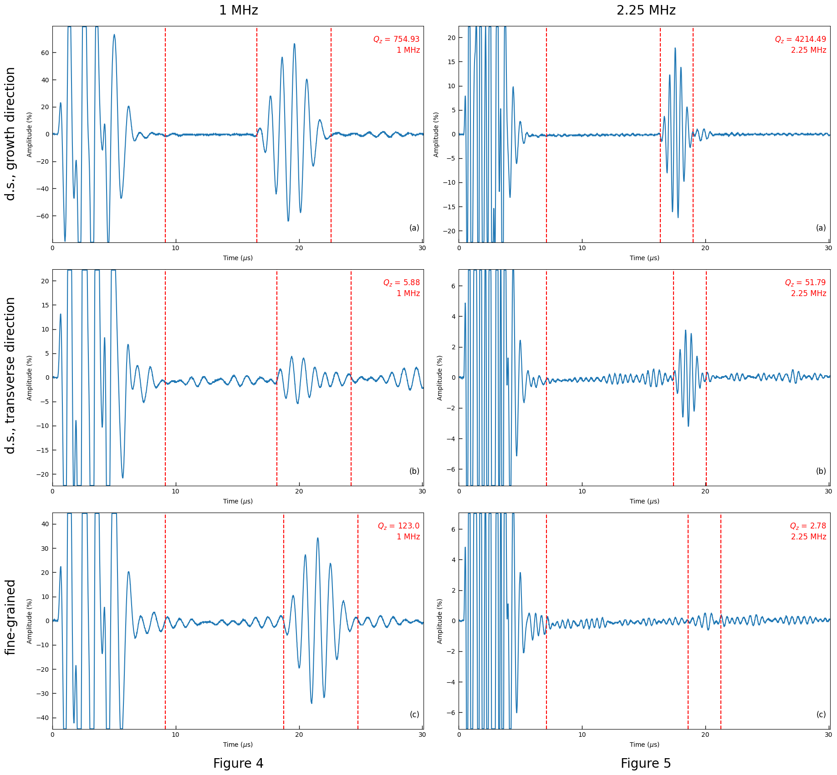

Figures 4 and 5. Representative pulse and first echo waveforms at 1.0 MHz (Figure 4, first column) and 2.25 MHz (Figure 5, second column). The first row (a) is the growth direction of a directionally solidified alloy cube, the second row (b) is in the transverse direction of a directionally solidified cube, and the third row (c) is for a fine-grained cube. The first vertical dashed red line represents the beginning of the reflected scattering interval, the second is the end of the reflected scattering interval and the beginning of the transmitted pulse interval, and the third is the end of the transmitted pulse interval. The *QZ* for each waveform is calculated in the upper right of each plot.

## 3.3. Scattering Attenuation

Figures 4 and 5 show representative waveforms of the incident compressional wave pulse, reflected scattering, and the first transmitted pulse intervals at frequencies of 1.0 and 2.25 MHz. The waveforms are for the growth and one transverse direction of a d.s cube, and for one direction of an isotropic f.g. cube. Table 3 gives the average scattering quality factor

*QZ = (R + T)/R* of the nine spots in the 3-by-3 grid for each cube in each direction for these two frequencies, where, once again, *R* is the average reflected (scattered) energy per cycle, and *T* is the average transmitted energy per cycle. It also gives the lower and upper values of *QZ* of the nine spots that make up the average. A higher *QZ* indicates less scattering. Despite the significant variability in the *QZ* values across the nine spots averaged for each entry, as indicated by the range in the parentheses in Table 3, we believe this variability is low enough to make the differences between different microstructures and directions (when relevant) meaningful. The transverse directions of the d.s. cubes exhibit the most variability because the larger grains result in a fewer number of crystals, making the *Va-c* approximation in Table 2 worse. In general, maximum scattering (*Pierce, 1989*) occurs when the grain width *d* and wavelength *λ* satisfy the condition

*2πd ≅ λ*, (4)

known as Mie scattering.

| **Cube, direction \ frequency** | **1 MHz** | **2.25 MHz** |
| --- | --- | --- |
| d.s. cube 1 growth | 530 (100-1386) | 1014 (29-4215) |
| d.s. cube 2 growth | 516 (55-1150) | 1194 (328-2549) |
| **d.s. growth average** | **523** | **1104** |
| d.s. cube 1 transverse 1 | 21 (1.0-96) | 66 (1.1-423) |
| d.s. cube 1 transverse 2 | 77 (9.1-210) | 173 (15-536) |
| d.s. cube 2 transverse 1 | 7.6 (1.1-23) | 7.2 (1.4-29) |
| d.s. cube 2 transverse 2 | 36 (4.7-130) | 43 (4.1-225) |
| **d.s. transverse average** | **35** | **71** |
| f.g. cube 3 vertical | 60 (4.2-163) | 2.1 (1.3-2.7) |
| f.g. cube 3 side | 97 (8.4-255) | 2.0 (1.5-2.6) |
| f.g. cube 4 vertical | 210 (30-391) | 2.8 (1.9-3.9) |
| f.g. cube 4 side | 120 (54-223) | 1.2 (1.1-1.3) |
| **f.g. average** | **122** | **2.0** |

Table 3. Average scattering quality factor *QZ* for each cube in different directions and frequencies. Values in parenthesis are the lower and upper values of *QZ* of the nine spots that make up each average.

At 1.0 MHz, directionally solidified (d.s.) cubes in the growth direction exhibit significantly less scattering compared with the transverse directions, as was observed qualitatively by Bergman *et al.* (*2000*). The overall mean *QZ* = 523 in the growth direction, whereas *QZ* = 35 in the transverse directions. For fine-grained (f.g.) cubes, the overall mean *QZ* = 122. The very high *QZ* in the growth direction of the d.s. alloys is a result of waves having to cross few (or sometimes zero!) grain boundaries, *i.e.*, with *2πd/λa* >> 1 (Table 2: *λa* = 4.8 mm), the conditions are in the short wavelength limit, and the grains are crystallographically aligned in this direction. The low *QZ* in the transverse directions is a result of waves having to cross grain boundaries with large acoustic impedance mismatch due to single crystal elastic anisotropy (the c-axes are randomly oriented in the direction transverse to growth) and *2πd/λa-c* ≳ 10 (Table 1:

*d* = 6.6 - 10 or more mm; Table 2: *λa-c* = 3.7 mm). For the f.g. alloys, *2πd/λReuss* ≅ .25 (*d* = .20 mm, *λReuss* = 3.9 mm), slightly on the Rayleigh scattering side of the condition for maximum scattering. Although relatively close to this condition, because in the f.g. alloys, the isotropic basal planes are randomly oriented in all directions, the impedance mismatch between crystals is, on average, less than in the transverse directions of the d.s alloys, resulting in an intermediate value of *QZ*.

At 2.25 MHz, *2πd* is even longer than *λ* for the directionally solidified alloys, and *QZ* approximately doubles from 1.0 to 2.25 MHz, except for the transverse directions of cube 2. However, from 1.0 to 2.25 MHz, the scattering quality factor drops precipitously for the f.g. cubes to an overall mean *QZ* = 2.0. This is because the condition is very close to maximum scattering, with *λReuss* = 1.7 mm and *2πd* = 1.26 mm. Although a surprisingly small value, it is based on nine spots on each of the two faces of two cubes, so we believe it to be a robust result.

At 5.0 and 10.0 MHz, *QZ* drops significantly for the d.s. cubes in both the growth and transverse directions. However, we do not believe these are accurate measures of scattering because of severe ringing. For example, a large secondary incident pulse appears (Figure 6). This results in random noise mimicking scattering, thereby lowering the measured *QZ*. For the f.g. cubes, *QZ* at 5.0 MHz stays roughly the same as at 2.25 MHz, increasing slightly at 10.0 MHz. It is interesting to speculate that this is because at 5.0 and 10.0 MHz, *λReuss* = .78 and .39 mm, respectively, are now shorter than *2πd* = 1.26 mm, and *QZ* might then increase with a yet shorter wavelength. However, since the stated upper-frequency range of the RHP-8000 toneburst pulser is 6.0 MHZ, the reliability of these higher-frequency measurements is questionable.

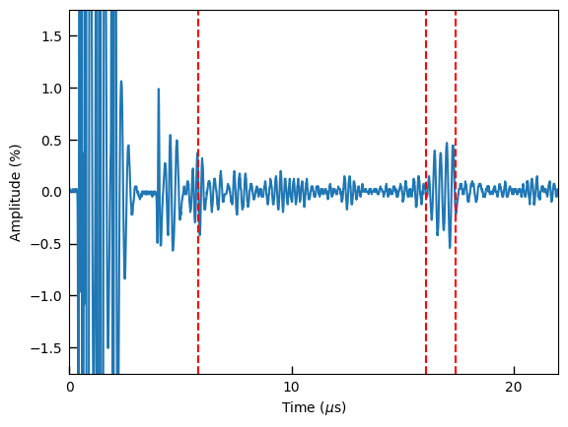

Figure 6. Waveform at 5.0 MHz in the d.s. growth direction, showing ringing in the initial pulse.

There is a broad range in the nine *QZ* values that contribute to each average in Table 3. For the d.s. alloys, the range of *QZ* is likely real: each of the nine spots could well be sampling slightly differently oriented (both in c-axis orientation and tilt), large, columnar crystals. Variations in the surface preparation, which can affect the coupling of the transducer to the cube, could also affect *QZ*. Poor coupling results in a weak signal, lowering the measured *QZ*, though we note that the wavelength of all measurements far exceeded the final polished roughness. In summary, despite only having nine values for each face of each cube at each frequency, so that one cannot calculate a standard deviation, we believe the *QZ* values for each microstructure cluster sufficiently for them to be meaningful, at least at 1.0 and 2.25 MHz.

# Discussion

In this study, we introduce a scattering attenuation quality factor *QZ* that is an experimental measure of the ratio of the total energy per cycle to scattered energy per cycle, akin to the intrinsic attenuation quality factors for shear *Qμ* and bulk *Qκ*. The total attenuation should add in inverse, as in Equation (3). Using the ultrasonic pulse-echo technique with compressional waves on an hcp Zn-rich Sn alloy at room temperature and atmosphere pressure, we measured the transmitted and reflected energies to calculate *QZ* for different microstructures at different frequencies. This Zn-Sn alloy serves as an analog for the hcp Fe alloy that is arguably present in the inner core (*Tateno et al., 2010*), allowing us to use samples large enough to study scattering for plausible inner core microstructures: dendritic, textured, columnar crystals and untextured, fine-grained, equiaxed crystals.

For the frequencies with good input signal quality, 1.0 and 2.25 MHz, the growth direction of the directionally solidified alloys exhibits a very high *QZ*, typically greater than 500 at 1.0 MHz and often exceeding 1000 at 2.25 MHz, as a result of the elongated crystals in that direction, with few grain boundaries. Moreover, the growth direction of the elongated crystals generally lies close to parallel to the basal plane, resulting in a small acoustic impedance contrast between crystals. In this study, *2πd/λ* >>1 in the growth direction at both frequencies.

On the other hand, the transverse directions exhibit a very low but variable *QZ*, ranging from *QZ* = 1.0 to *QZ* = 210, with a mean *QZ* = 35 at 1.0 MHz, and ranging from *QZ* = 1.1 to *QZ* = 536, with a mean *QZ* = 72 at 2.25 MHz. The low *QZ* results from the occasional large contrast in acoustic impedance, as the c-axes between crystals can be randomly oriented in the transverse directions. The large variability of *QZ* results from these arbitrary rotations and the relatively small number of crystals in our sample cubes. With *2πd/λ ≳ 10* at 1.0 MHz and *2πd/λ ≳ 20* at 2.25 MHz, the transverse directions, like the growth direction, are in the short wavelength limit.

For the untextured, fine-grained, equiaxed alloy at 1.0 MHz, the mean *QZ* = 122, intermediate between the growth and transverse directions of the directionally solidified alloys because the isotropic basal planes are randomly oriented in all directions, so that the impedance mismatch between crystals is, on average, less than in the transverse directions of the directionally solidified alloys. At this frequency, *2πd/λ* ≅ .25, which is on the long wavelength side of the condition for maximum scattering. At 2.25 MHz, the mean *QZ* = 2.0, a small but robust value, based on the number of measurements and the small variability. At this frequency, *2πd/λ* = .74, which is very close to the condition of maximum scattering attenuation.

We proffer a few further small caveats on our measured *QZ*: Although *R* and *T* are defined per cycle, *i.e.*, by their energy per time interval, we were unable to test how independent our *QZ* is relative to the path length. Our furnace limits the maximum size of the cubes we can make. Meanwhile, the requirement that the transducer be smaller than a cube face and the wavelength be much smaller than a cube edge limits the minimum size (these also make it difficult to use transducers of lower frequencies due to their size). Because the cumulative intrinsic attenuation increases with path length, and the pulse reflected off the cube's back side must travel further than backward scattered energy, our method could underestimate *QZ*, particularly at higher frequencies. On the other hand, we did not include in our calculation of *QZ* forward scattered energy that appears as a coda after the echo.

It is relatively straightforward to extrapolate *QZZn* from our experiments to the inner core. *QZ = (R + T)/R = 1 + T/R ≈ T/R* in the limit of large *QZ*. From basic wave theory, *T/R = 4Z1Z2/(Z1 - Z2)2* for a single interface, where *Z1* and *Z2* are the acoustic impedances of the two media. For an anisotropic hcp media, *QZ* is thus proportional to *VaVc/(Va - Vc)2*, with the constant of proportionality depending on the geometrical arrangement of the crystals. Since these experiments examine microstructures that might be relevant to the inner core, we can assume the same constant of proportionality. Hence,

*QZIC/QZZn = [ (VaICVcIC) / (VaIC - VcIC)2 ] / [ (VaZnVcZn) / (VaZn - VcZn)2 ]*. (5)

The elastic constants of hcp Fe under inner core conditions are uncertain. Lincot *et al*. (*2016*) fit seismic models of inner core anisotropy by incorporating inner core solidification, stratification, and polycrystal deformation and using single crystal anisotropy with *VcIC - VaIC* between 5% and 20%. Although they also included a parameter for *VIC* at 45 degrees from the c-axis, they found *VcIC - VaIC* primarily controls the anisotropy pattern. Therefore, for simplicity, we will use Equation (5), with *VcIC* = 11.55 km/s, *VaIC* = 10.45 km/s, and *(VcIC - VaIC)/VICaverage* = 10%. Using *VaZn* and *VcZn* from Table 2, we find *QZIC/QZZn* ≅ 40, for a given wavelength and microstructure. The large ratio is a result of the large single-crystal anisotropy of Zn compared with its average compressional wave velocity, but obviously this ratio is highly dependent on the elastic constants of Fe (*Antonangeli et al., 2006; Martorell et al., 2013; Li & Scandolo, 2022*).

To apply the experimental results to estimate *QZIC*, one must also know the inner core grain size and shape. For dendritic, textured, columnar crystals that result from directional solidification, the dendrite spacing scales as *(dx/dt)-¼(dT/dx)-½* (*Kurz & Fisher, 1992*), where *dx/dt* is the solid growth rate and *dT/dx* is the temperature gradient. With *dT/dx* = 680 K/m and a cooling rate *dT/dt* = 1 K/min, *dx/dt* = *(dT/dt)/(dT/dx)* = 2.5 x 10-5 m/s for the directionally solidified Zn alloys. For the inner core, we use *dx/dt* = 1200 km/500 million years, though, of course, estimates for the age of the inner core vary highly (*Cormier et al., 2022*). We estimate *dT/dx* at the inner core boundary to be about 200 K/1200 km (*Cormier et al., 2022*). The ratio of the dendrite spacing in the inner core to that in the lab-grown alloys *[(dx/dt)-¼(dT/dx)-½]IC / [(dx/dt)-¼(dT/dx)-½]Zn* is thus of order 105, and with the dendrite spacing in the lab being between .1 and 1 mm, the dendrite spacing in the inner core extrapolates to tens of meters, which is consistent with compositional gradients in Fe meteorites (*Esbensen & Buchwald, 1982*). With columnar crystals typically composed of tens of dendrites, one obtains an inner core transverse grain width of hundreds of meters. Based on aspect ratios of unconstrained growth in the lab, the grain size in the growth direction in the inner core is likely tens of kilometers.

At 1 Hz, the compressional body wavelength *λ* ≅ 10 km in the inner core. For the growth direction of a directionally solidified alloy, *2πd* almost certainly exceeds *λ* (the short wavelength limit, unusual in deep Earth geophysics), making our 1.0 MHz results applicable. Moreover, in the growth direction, grain boundaries do not present impedance contrasts. Scaling our experimental results by the relative impedance contrasts, we thus estimate *QZIC* > 20,000, so that intrinsic attenuation clearly dominates scattering attenuation in the growth direction of columnar crystals.

For the transverse directions of a directionally solidified alloy, our experimental results at 1.0 MHz (for which *2πd* exceeds *λ* by more than 10, *i.e.*, the short wavelength limit) give an average *QZZn* = 35, which scales to *QZIC* = 1400. However, in the transverse directions of inner core columnar crystals, *λ* more likely exceeds *2πd* by a factor of less than 10 (slightly on the long wavelength limit). The results for the fine-grained cubes at 2.25 MHz (*QZZn* = 2.0) may thus be more applicable. Moreover, with the c-axes orienting randomly only in the transverse plane, the average impedance contrast in the transverse directions is larger than in the f.g. alloys, resulting in a smaller *QZIC*. Based on this, we estimate 80 < *QZIC* < 1400 in the transverse directions, with the actual value likely towards the lower end, resulting in a highly anisotropic inner core *QZIC* for dendritic, textured, columnar crystals such as arise from directional solidification.

Finer-grained, equiaxed crystals are more likely formed through deformation and possible dynamic recrystallization. Using intermediate values for a range of metallic alloys for the growth exponent and mobility (*Humphreys & Hatherly, 2004*), Bergman *et al.* (*2010*) estimated that recrystallization of directionally solidified alloys, driven by the high surface energy associated with dendrites, results in a grain size of .5 km after 50 million years (the irony of calling such a crystal size ‘fine-grained’ is not lost on us). Yamazaki *et al.* (*2017*) experimentally determined the growth rate of hcp Fe at 55 GPa and 1200–1500 K, and by extrapolating to core conditions, they estimated a grain size of hundreds of meters to a few kilometers.

Scaling the experimental results for the f.g. alloy at 2.25 MHz, which is close to the condition of maximum scattering, *QZIC* ≅ 80 for *λ* = 10 km and crystals sizes between roughly .5 km and a few kilometers. If deformation produces a texture, as suggested by elastic anisotropy, then *QZIC* would also be anisotropic. Based on the experimental results at 1.0 MHz, *QZIC* rises to 4800 for fine-grained crystals in the inner core much smaller than .5 km (the long wavelength limit), large enough that scattering would likely be a small contributor to the overall inner core attenuation. In the unlikely case that fine-grained crystals produced by deformation and/or recrystallization exceed a few kilometers (the short wavelength limit), *QZIC* would also increase from its minimum value of around 80. Our estimate of the grain size range that produces the maximum scattering is in agreement with that inferred by Wu *et al.* (*2022*) using seismic stacking from small-aperture arrays.

The extreme sensitivity of *QZ* to the grain size is a result of the intensity of Rayleigh scattering (the long wavelength limit) scaling as *(d/λ)4* for spherical scatterers (*Pierce, 1989*). This makes body waves an excellent probe for inferring the inner core grain size and shape. It also suggests, unsurprisingly, that inner core attenuation of normal modes is almost entirely intrinsic. With body waves inferring a global *QP* = 200 - 400 in the upper inner core (*Pejic et al., 2017*), a *QZIC* as low as 80 is not possible. It is possible that our experimental method underestimates *QZZn*, or that our choice of *(VcIC - VaIC)/VICaverage* = 10% is too large, so that *QZIC/QZZn* is greater than 40. Alternatively, the globally averaged grain size could be somewhat less than about .5 km, or larger than a few kilometers. In any case, elongated columnar crystals (*i.e.*, having a shape-preferred orientation) and a lattice-preferred orientation can produce a strongly anisotropic *QZ*.

Hemispherical and smaller-scale lateral variations support the role of scattering for body wave attenuation because lateral variations of *QP* are more likely due to scattering variations from different microstructures, which depends on the solidification and deformation history, rather than intrinsic attenuation, which is more primarily a function of composition, phase, temperature, and pressure that are less likely to vary laterally. For instance, in the more attenuating eastern hemisphere, where *QP* is as low as 160, the grain size is likely very close to the condition of maximum scattering, between .5 km and a few kilometers.

Finally, Souriau (*2009*) found evidence for a frequency-dependent body wave *VP* along polar paths but not in equatorial paths. Calvet & Margarin (*2018*) showed using multiple scattering theory that by keeping the grain volume constant and with no lattice-preferred orientation, but allowing for a shape-preferred orientation, one can obtain the observed correlation between high velocity and high attenuation, which could also explain hemispherical and lateral variations. Because our columnar microstructure with a shape-preferred orientation also has a lattice-preferred orientation, the latter dominates elastic anisotropy, and we did not observe dispersion.

Although the exact values of *QZIC* and hence of grain sizes and shapes that we predict from our experiments may evolve as we gain more precise knowledge of the elastic constants of Fe under inner core conditions, this study gives a framework to interpret seismic results in terms of inner core microstructure and hence evolution.

# References

Anderson, D.L., Theory of the Earth, Blackwell Scientific, Boston, 1989.

Antonangeli, D., Merkel, S., Farber, D.L., Elastic anisotropy in hcp metals at high

pressure and the sound wave anisotropy of the Earth’s inner core, Geophys.

Res. Lett., 33, doi:10.1029/2006GL028237, L24303, 2006.

Belonoshko, A.B., Lukinov, T., Fu, J., Zhao, J., Davis, S., Simak, S., Stabilization of

body-centered cubic iron under inner-core conditions, Nature Geoscience, 10,

312, 2017.

Bergman, M.I., Measurements of elastic anisotropy due to solidification texturing and

the implications for the Earth’s inner core, Nature, 389, 60-63, 1997.

Bergman, M.I., Estimates of the Earth’s inner core grain size,

Geophys.Res.Lett., 25,1593-1596, 1998.

Bergman, M.I., Giersch, L., Hinczewski, M., Izzo, V. Elastic and attenuation anisotropy

in directionally solidified hcp zinc, and the seismic anisotropy in the Earth’s inner

Core, Phys. Earth Planet. Int., 117, 139–151, 2000.

Bergman, M. I., Agrawal, S., Carter, M., Macleod-Silberstein, M., Transverse

solidification textures in hexagonal close-packed alloys, J. Crystal Growth, 255,

204-211, 2003.

[Bergman](https://agupubs.onlinelibrary.wiley.com/authored-by/Bergman/Michael+I.), M.I., [Lewis](https://agupubs.onlinelibrary.wiley.com/authored-by/Lewis/Daniel+J.), D.J., [Myint](https://agupubs.onlinelibrary.wiley.com/authored-by/Myint/Ingyin+Hla), I.H., [Slivka](https://agupubs.onlinelibrary.wiley.com/authored-by/Slivka/Liam), L., [Karato](https://agupubs.onlinelibrary.wiley.com/authored-by/Karato/Shun%E2%80%90ichiro), S.-I., [Abreu](https://agupubs.onlinelibrary.wiley.com/authored-by/Abreu/Andrew), A., Grain growth

and loss of texture during annealing of alloys, and the translation of Earth’s inner

core, Geophys. Res. Lett., 37, <https://doi.org/10.1029/2010GL045103>, 2010.

Bhadwal, N., Milani, M.T., Coyle, T., Sinclair, A., Dry Coupling of Ultrasonic Transducer

Components for High Temperature Applications, Sensors, 19, <https://doi.org/10.3390/s19245383>, 5383, 2019**.**

Calvet, M., Margerin, L., Constraints on grain size and stable iron phases in the

uppermost inner core from multiple scattering modeling of seismic velocity and

attenuation, Earth Planet. Sci. Lett., 267, 200-212, 2008.

Calvet, M., Margerin, L., Shape preferred orientation of iron grains compatible with

Earth’s uppermost inner core hemisphericity, Earth Planet. Sci. Lett., 481,

395-403, 2018.

Cao, A., Romanowicz, B., Constraints on shear wave attenuation in the Earth's inner

core from an observation of PKJKP, Geophys. Res. Lett. 36,

doi: 10.1029/2009GL038342, 2009.

Cormier, V.F., Texture of the uppermost inner core from forward- and back-scattered

seismic waves, Earth Planet. Sci. Lett., 258, doi:10.1016/j.epsl.2007.04.003,

442-453, 2007.

Cormier, V.F., Bergman, M.I., Olson, P.L., Earth’s core: Geophysics of a planet’s

deepest interior, Elsevier, Amsterdam, 2022.

Cormier, V.F., Li, X., Frequency-dependent seismic attenuation in the inner core. II. A

scattering and fabric interpretation, J. Geophys. Res., 107, doi:10.1029/2002JB001796, 2002.

Cormier, V.F., Li, X., Choy, G.L., Seismic attenuation of the inner core: viscoelastic or

stratigraphic, Geophys. Res. Lett., 25, 4019-4022, 1998.

Deuss, A., Heterogeneity and anisotropy of Earth’s inner core, Annu. Rev. Earth Planet.

Sci., 42, 103-126.

Dziewonski, A.M., Anderson, D.L., Preliminary reference Earth model, Phys. Earth

Planet. Int., 25, 297-356, 1981.

Esbensen, K.H., Buchwald, V.F., Planet(oid) core crystallisation and fractionation -

evidence from the Agpalilik mass of the Cape York iron meteorite shower, Phys.

Earth Planet. Int., 29, 218- 232, 1982.

Humphreys, F.J., Hatherly. M., Recrystallization and Related Annealing Phenomena,

2nd ed., Elsevier, Amsterdam, 2004.

Iratani, R.N., Takeuchi, N., Kawakatsu, H., Intricate heterogeneous structures of the top

300 km of the Earth’s inner core inferred from global array data: II. Frequency

dependence of inner core attenuation and its implication, Earth Planet. Sci. Lett,

405, doi:10.1016/j.epsl2014.08.038, 231-243, 2014.

Kennett, B.L.N., Engdahl, E.R, Buland, R., Constraints on seismic velocities in the Earth

from traveltimes, Geophys. J. Int.,122,

<https://doi.org/10.1111/j.1365-246X.1995.tb03540.x>, 108–124, 1995.

Kurz, W., Fisher, D.J., Fundamentals of Solidification, 3rd ed., Trans Tech, Switzerland,

1992.

Leyton, F. Koper, K.D., Using PKiKP coda to determine inner core structure: 2.

Determination of QC, J. Geophys. Res., 112, <https://doi.org/10.1029/2006JB004369>, 2007.

Li, Z., Scandolo, S., Elasticity and viscosity of hcp iron at Earth's inner core conditions

from machine learning-based large-scale atomistic simulations, Geophys. Res.

Lett., 49, e2022GL101161. https://doi.org/10.1029/2022GL101161, 2022.

Lincot, A., Cardin, P., Deguen, R., Merkel, S., Multiscale model of global inner-core

anisotropy induced by hcp alloy plasticity, Geophys. Res. Lett., 43, doi:10.1002/2015GL067019,1084–1091, 2016.

Makinen, A.M., Deuss, A., Normal mode splitting due to inner core attenuation

anisotropy, Geophys. J. Int., 195, 1786-1795, 2013.

Makinen, A.M., Deuss, A., Redfern, S.A.T., Anisotropy of Earth’s inner core intrinsic

attenuation from normal mode models, Earth Planet. Sci. Lett., 404, 354-364,

2014.

Martorell, B., Brodholt, J., Wood, I.G., Vočadlo, L., The effect of nickel on the properties

of iron at the conditions of Earth's inner core: *Ab initio* calculations of seismic wave velocities of Fe–Ni alloys, [Earth Planet. Sci. Lett](https://www.sciencedirect.com/journal/earth-and-planetary-science-letters)., [365](https://www.sciencedirect.com/journal/earth-and-planetary-science-letters/vol/365/suppl/C), <https://doi.org/10.1016/j.epsl.2013.01.007>, 143-151, 2013.

McSkimin, H.J., Ultrasonic Measurement Techniques Applicable to Small Solid

Specimens, J. Acoust. Soc. Am., 22, <https://doi.org/10.1121/1.1906618>,

413–418, 1950.

Morelli, A., Dziewonski, A.M., Woodhouse, J.H., Anisotropy of the inner core inferred

from *PKIKP* travel times, Geophys. Res. Lett., 13,

<https://doi.org/10.1029/GL013i013p01545>,1545-1548, 1986.

Mozorov, I.G., On the relation between bulk and shear seismic dissipation, Bull.

Seismol. Soc. Am., 105, 3180-3188, 2015.

Pejic, T., Tkalcic, H., Sambridge, M., Cormier, V.F., Benavente, R., Attenuation

tomography of the upper inner core, J. Geophys. Res., 122,

doi:10.1002/2016JB013692, 3008-3032, 2017.

Pierce, A.D., Acoustics, Acoustical Society of America, Woodbury, NY, 1989.

Poupinet, G., Kennett, B.L.N., On the observation of PKiKP and its high frequency coda

on the Warramunga array, Australia, Phys. Earth Planet. Int., 146, 497-512, 2004.

Poupinet, G., Pillet, R., Souriau, A., Possible heterogeneity of the Earth's core deduced

from PKIKP travel times, Nature, 305, doi:[10.1038/305204a0](http://dx.doi.org/10.1038/305204a0), 204-206, 1983.

Romanowicz, B. Mitchell, B., Deep Earth structure: Q of the Earth from crust to core, in

Treatise on Geophysics, ed. Schubert, G., Elsevier, 731-774, 2007.

Roth, E.G., Wiens, D.A., Zhao, D., An empirical relationship between seismic

attenuation and velocity anomalies in the upper mantle, Geophys. Res. Lett., 27,

601-604, 2000.

Simmons, G., Wang, H., Single crystal elastic constants and calculated aggregate

properties: A Handbook, 2nd ed., MIT, Cambridge, 1971.

Souriau, A., Inner core structure: Constraints from frequency dependent seismic

anisotropy, C.R. Geoscience, 341, 439-445, 2009.

Souriau, A., Romanowicz, B., Anisotropy in inner core attenuation: a new type of data to

constrain the nature of the solid core, Geophys. Res. Lett., 23, 1-4, 1996.

Souriau, A., Romanowicz, B., Anisotropy in the inner core: relation between P-velocity

and attenuation, Phys. Earth Planet. Int., 101, 33-47, 1997.

Talavera-Soza, S., Deuss, A., Constraining 1-D inner core attenuation through

measurements of strongly coupled normal mode pairs, Geophys. J. Int., 223,

612-621, 2020.

Tanaka, S., Depth extent of hemispherical inner core from PKP(DF) and PKP(Cdiff) for

equatorial paths, Phys Earth Planet. Int., 210-211, 50-62, 2012.

Tanaka, S. Hamaguchi, H., Degree one heterogeneity and hemispherical variation of

anisotropy in the inner core from PKP(BC) - PKP(DF) travel times, J. Geophys.

Res., 102, doi:1029/96JB03187, 2925-2938, 1997.

Tateno, S., Hirose, K., Ohihi, Y., Tatsumi, Y.,The structure of iron in Earth's inner core,

Science, 330, [10.1126/science.1194662](https://doi.org/10.1126/science.1194662), 359-361, 2010.

Tkalcic, H., Complex inner core of the Earth: the last frontier of global seismology, Rev.

Geophys., 53, 59-94.

Vidale, J.E., Earle, P.S., Fine-scale heterogeneity in the Earth’s inner core, Nature, 404,

273-275, 2000.

Vocadlo, L., Alfe, D., Gillan, M.J., Wood, I.G., Brodholt, J.P., Price, G.D., Possible

thermal and chemical stabilization of body-centered-cubic iron in the Earth's core,

Nature, 424, [10.1038/nature01829](https://doi.org/10.1038/nature01829), 536-539, 2003.

Wang, S., Tkalcic, H., Shear-wave anisotropy in the Earth’s inner core, Geophys. Res.

Lett., 48, e2021GL094784, 2021.

Wang, W., Vidale, J.E., An initial map of the fine-scale heterogeneity in the Earth’s inner

core, Nature Geosc., 1(3), <https://doi.org/10.1038/s41561-022-00903-8>, 240-244, 2022.

Wen, L., Niu, F., Seismic velocity and attenuation structures in the top of the Earth’s

inner core, J. Geophys. Res., 107, doi:10.1029/2001JB000170, 2273, 2002.

Widmer, R., Masters, G., Gilbert, F., Spherically symmetric attenuation within the Earth

from normal mode data, Geophys. J. Int., 104, 541-553, 1991.Woodhouse, J.H., Woodhouse, J.H., Giardini, D., Li, X.-D., Evidence for inner core anisotropy from free

oscillations, Geophys, Res. Lett., 13, <https://doi.org/10.1029/GL013i013p01549>,

1549-1552, 1986.

Wookey, J., Helffrich, G., Inner-core shear-wave anisotropy and texture from an

observation of PKJKP waves, Nature, 454, 873-876, 2008.

Wu, S.-M., Pang, G., Koper, K.D., Euler, G., A search for large-scale variations in the

fine-scale structure of Earth’s inner core, J. Geophys. Res, 127, <https://doi.org/10.1029/2022JB024420>, 2022.

Wu, W., Irving, J.C., Using PKiKP coda to study heterogeneity in the top layer of the

inner core’s Western hemisphere, Geophys. J. Int., 209, <https://doi.org/10.1093/gji/ggx047>, 672-687, 2017.

Yamazaki, D., Tsujino, N., Yoneda, A., Ito, E., Yoshino, T., Tange, Y., Higo, Y., Grain

growth of epsilon-iron: Implications to grain size and its evolution in the Earth's

inner core, Earth Planet. Sci. Lett., 459, 238-243, doi:10.1016/j.epsl.2016.11.049,

2017.

Yee, T.-G., Rhie, J., Tkalcic, H., Regionally heterogeneous uppermost inner core

observed with Hi-net array, J. Geophys. Res., 119, doi:10.1002/2014JB0011341,

7823-7845, 2014.